Student’s Name: Kibet Brian
Admission Number: 190814
Lecturer’s Name: Mr. Talo Harrison
Course Unit: MST 8303 Penetration Testing, PT
Course Code: MST 8303
Lab - Installing NESSUS Using Docker
Date: July 8th, 2025
Lab - Installing NESSUS Using Docker
Docker is already installed.
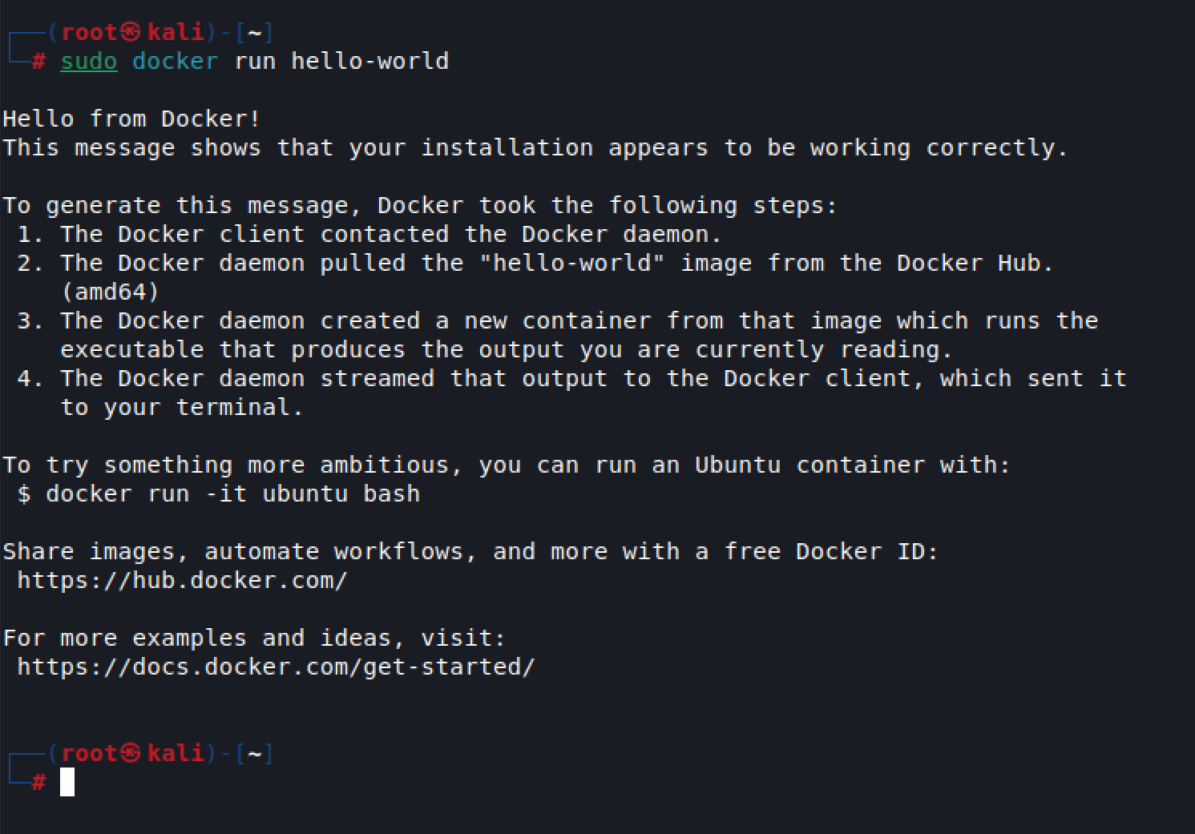

Downloading the Docker NESSUS image
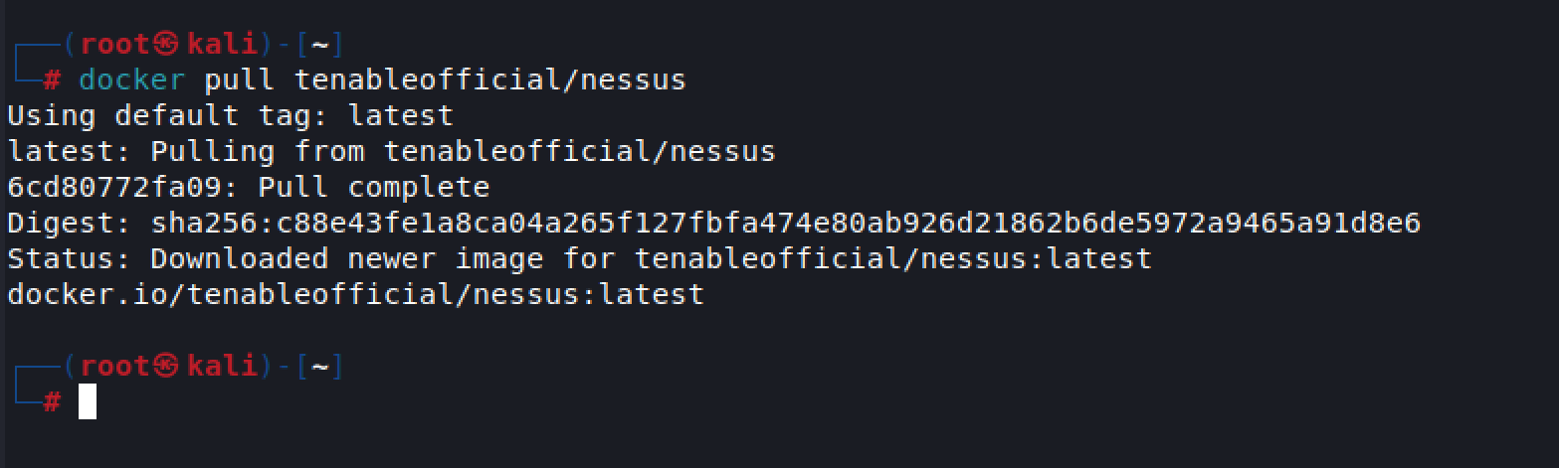

Creating a container to run our image of NESSUS and confirming the image is running.
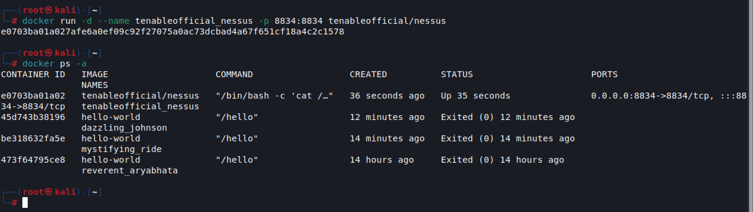

Restarting my previous NESSUS image.
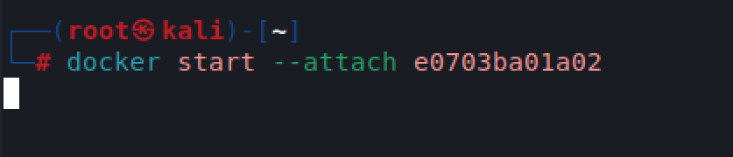

Accessing the web interface for NESSUS.
